Note:- read the lab programs(2&3)
- Explain the architecture of the CNN.
Architecture of CNN

neurons are fully connected between different layers. Layers that sit between the input layer and output layer are called hidden layers. Each hidden layer is made up of a number of neurons, where each neuron is fully connected to all neurons in the preceding layer

Convolutional neural network is a deep neural network architecture designed to process data that has a known, grid-like topology, for example, 1D time-series data, 2D or 3D data such as images and speech signal, and 4D data such as videos.

ConvNets have three key features:
1)local receptive field,
2)weight sharing, and
3) subsampling(pooling).

(i) Local Receptive Field:

Convolutional neural networks, however, have local receptive field architecture, i.e., each hidden unit can only connect to a small region of the input called local receptive field. This is accomplished by making the filter/weight matrix smaller than the input. With local receptive field, neurons can extract elementary visual features like edges, corners, end points.

(ii) Weight Sharing:
Weight sharing refers to using the same filter/weights for all receptive fields in a Layer.

ConvNet consists of a sequence of different types of layers to achieve different
tasks. A typical convolutional neural network consists of the following layers:
• Convolutional layer,
• Activation function layer (ReLU),
• Pooling layer,
• Fully connected layer and
• Dropout layer

These layers are stacked up to make a full ConvNet architecture.
Convolutional and activation function layers are usually stacked together followed by an optional pooling layer.
Fully connected layer makes up the last layer of the network, and the output of the last fully connected layer produces the class scores of the input image.

(iii) Subsampling (Pooling):
Subsampling reduces the spatial size of the input, thus reducing the parameters in the network. There are few subsampling techniques available, and the most common subsampling technique is max-pooling.

- Explain the activation function and different types of activation functions.
The activation function layer consists of an activation function that takes the feature map
produced by the convolutional layer and generates the activation map as its output.
The activation function is used to transform the activation level of a neuron into an
output signal. An activation function usually has a squashing effect which takes an input (a number), performs some mathematical operation on it and outputs the activation level of a neuron between a given range, e.g., 0 to 1 or −1 to 1.

1)Logistic/Sigmoid Activation Function: The sigmoid function is mathematically
represented as
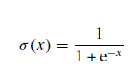

It is an S-shaped curve as shown in Fig. 2.6. Sigmoid function squashes the input
into the range [0, 1].

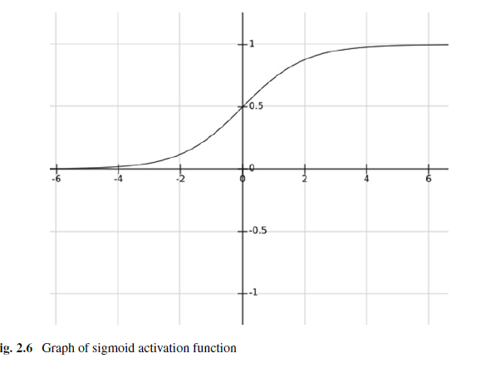

2) Tanh Activation Function: The hyperbolic tangent function is similar to sigmoid
function but its output lies in the range [−1, 1]. The advantage of tanh over sigmoid
is that the negative inputs will be mapped strongly negative and the zero inputs
will be mapped near zero in the tanh graph

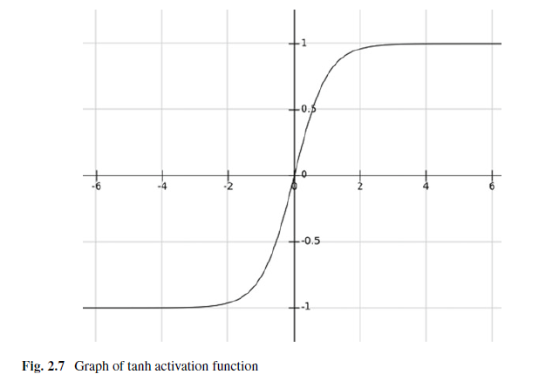

3) Softmax Function (Exponential Function): It is often used in the output layer
of a neural network for classification. It is mathematically represented as

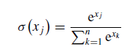

The softmax function is a more generalized logistic activation function which is
used for multiclass classification

4)ReLU Activation Function: Rectified Linear Unit (ReLU) has gained some importance in recent years and currently is the most popular activation function for deep neural networks. Neural networks with ReLU train much faster than other activation functions like sigmoid and tanh. ReLU simply computes the activation

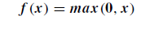
by thresholding the input at zero. In other words, a rectified linear unit has output
0 if the input is less than 0, and raw output otherwise. It is mathematically given
As

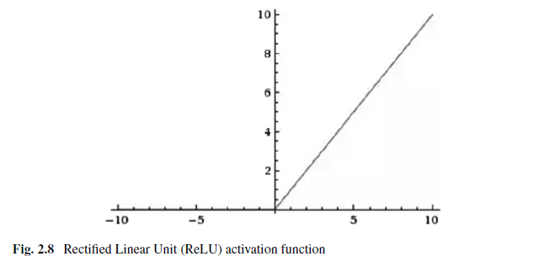

5)SWISH Activation Function: (Self-GatedActivation Function (SWISH) is actually a version of sigmoid function)

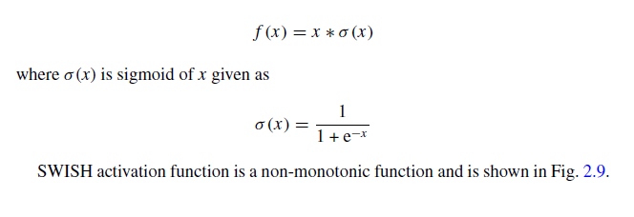

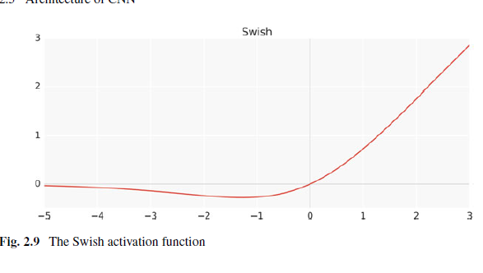

- Explain the evolution of CNN models.
1)LeNet: The first practical convolution-based architecture was LeNet which used backpropagation for training the network.LeNetwas designed to classify handwritten digits (MNIST), and it was adopted to read large numbers of handwritten checks in the United State.

ii)The main reasons for this limitation were as follows:
a. Small labeled datasets.
b. Slow computers.
c. Use of wrong nonlinearity (activation) function.
iii)Any deep neural network that uses a nonlinear activation function like sigmoid or tanh and is trained using backpropagation suffers from vanishing gradient.

iv)Vanishing gradient is a problem found in training the neural networks with gradient-based training methods. Vanishing gradient makes it hard to train and tune the parameters of the top layers in a neural network. The problem worsens as the total number of layers in the network increases.
2) AlexNet: The first breakthrough came in 2012 when the convolutional model which was named AlexNet significantly outperformed all other conventional methods in ImageNet Large-Scale Visual Recognition Competition (ILSVRC) 2012 that featured the ImageNet dataset

a. Large labeled image database (ImageNet), which contained around 15 million
labeled images from a total of over 22,000 categories, was used.

b. The model was trained on high-speed GTX 580 GPUs for 5 to 6 days.

c. ReLU (Rectified Linear Unit) f (x)_max(x, 0) activation functionwas used. This activation function is several times faster than the conventional activation functions like sigmoid and tanh. The ReLU activation function does not experience the vanishing gradient problem.

3) ZFNet: an improved version of CNN architecture called ZFNet was introduced.
ZFNet reduced the filter size in the first layer from 11 × 11 to 7 × 7 and
used a stride of 2 instead of 4 which resulted in more distinctive features and fewer dead features.
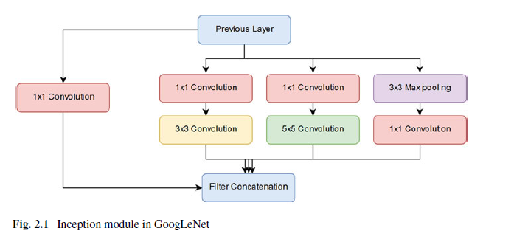
4) VGGNet: VGGNet, introduced in 2014, used increased depth of the network for improving the results. The depth of the network was made 19 layers by adding more convolutional layers with 3 × 3 filters, along with 2 × 2 max-pooling layers with stride and padding of 1 in all layers.

5) GoogLeNet: Google developed a ConvNet model called GoogLeNet in 2015. The
model has 22 layers and was the winner of ILSVRC 2015 for having the error rateof 6.7%.

The previous ConvNet models had convolution, and pooling layers stacked on top of each other but the GoogLeNet architecture is a little different. It uses an inception module which helps in reducing the number of parameters in the network.
The inception module is actually a concatenated layer of convolutions (3 × 3 and 5 × 5 convolutions) and pooling sub-layers at different scales with their output filter banks concatenated into a single output vector making the input for the succeeding stage.

Increasing the number of layers increases the number of features which enhances the accuracy of the network. However there is a practical limitation to that.
(1) Vanishing gradients: Some neurons in too deep networks may die during training which can cause loss of useful information and
(2)Optimization difficulty: too many parameters can make training the network a difficult task.

6) ResNet introduced residual connections in which the output of a conv-relu-conv series is added to the original input and then passed through Rectified Linear Unit (ReLU)
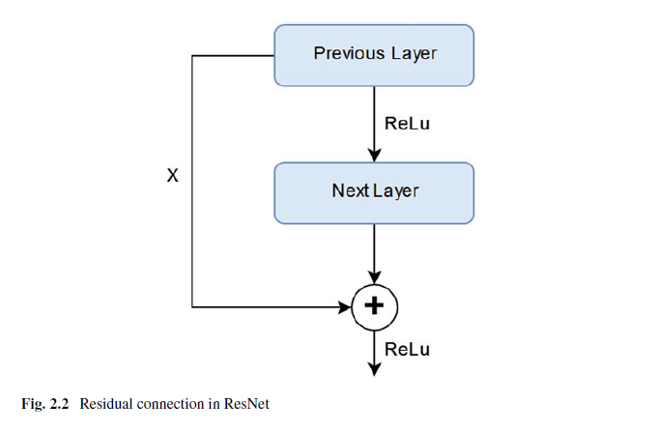

Fig. 2.2. In this way, the information is carried from the previous layer to the next layer and during backpropagation, the gradient flows easily because of the addition operations, which distributes the gradient. ResNet proved that a complex architecture like Inception is not required to achieve the best results but a simple and deep architecture can be tweaked to get better results.

7)Inception-ResNet: A hybrid inception model which uses residual connections, as in ResNet, was proposed in 2017. This hybrid model called Inception-ResNet dramatically
improved the training speed of inception model and slightly outperformed
the pure ResNet model by a thin margin.

8)Xception: A convolutional neural network architecture based on depth wise separable
convolution layers is called Xception. The architecture is actually inspired by inception model and that is why it is called Xception (Extreme Inception).

9)ShuffleNet: Another ConvNet architecture called ShuffleNet was introduced in 2017 for devices with limited computational power, like mobile devices, without compromising on accuracy. ShuffleNet used two ideas, pointwise group convolution and channel shuffle, to considerably decrease the computational cost while maintaining the accuracy.

- Explain the operations of CNN.

Convolution Operation

Convolution is a mathematical operation performed on two functions and is written
as (f * g), where f and g are two functions. The output of the convolution operation
for domain n is defined as

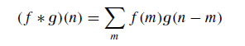

For time-domain functions, n is replaced by t. The convolution operation is commutative in nature, so it can also be written as

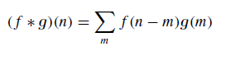

Convolution operation is one of the important operations used in digital signal processing and is used in many areas which includes statistics, probability, natural language processing, computer vision, and image processing.

Convolution operation can be applied to higher dimensional functions as well.It can be applied to a two-dimensional function by sliding one function on top of another, multiplying and adding.

An example of a two-dimensional filter, a two-dimensional input, and a two-dimensional feature map is shown in Fig. 2.4. Let the 2D input (i.e., 2D image) be denoted by A, the 2D filter of size m × n be denoted by K, and the 2D feature map be denoted by F. Here, the image A is convolved with the filter K and produces the feature map F. This convolution operation is denoted by A*K and is mathematically
given as

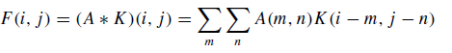

The convolution operation is commutative in nature, so we can written as

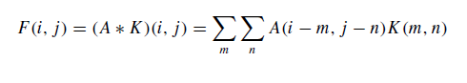
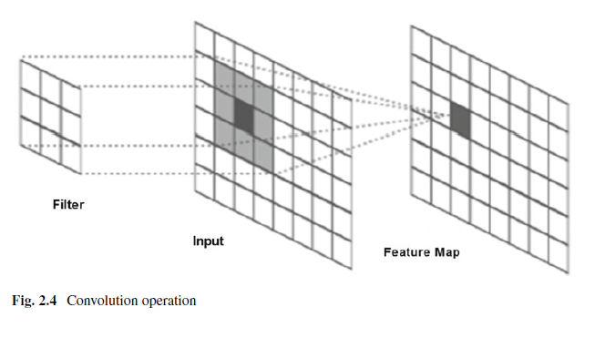
The kernel K is flipped relative to the input. If the kernel is not flipped, then
convolution operationwill be same as cross-correlation operation that is given below:

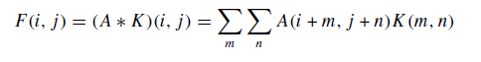

Many CNN libraries use cross-correlation function as convolution function because cross-correlation is more convenient to implement than convolution operation itself.

- What is weight sharing? Explain in deatail.

) Weight Sharing:
Weight sharing refers to using the same filter/weights for all receptive fields in a Layer.

ConvNet consists of a sequence of different types of layers to achieve different
tasks. A typical convolutional neural network consists of the following layers:
• Convolutional layer,
• Activation function layer (ReLU),
• Pooling layer,
• Fully connected layer and
• Dropout layer

These layers are stacked up to make a full ConvNet architecture.
Convolutional and activation function layers are usually stacked together followed by an optional pooling layer.
Fully connected layer makes up the last layer of the network, and the output of the last fully connected layer produces the class scores of the input image
Convolution Layer

Convolution layer is the core building block of a convolutional neural network which uses convolution operation (represented by *) in place of general matrix multiplication. Its parameters consist of a set of learnable filters also known as kernels.

The main task of the convolutional layer is to detect features found within local regions of the
input image that are common throughout the dataset and mapping their appearance to a feature map.

feature map is obtained for each filter in the layer by repeated application of the filter across subregions of the complete image .The input area on which a filter is applied is called local receptive field.

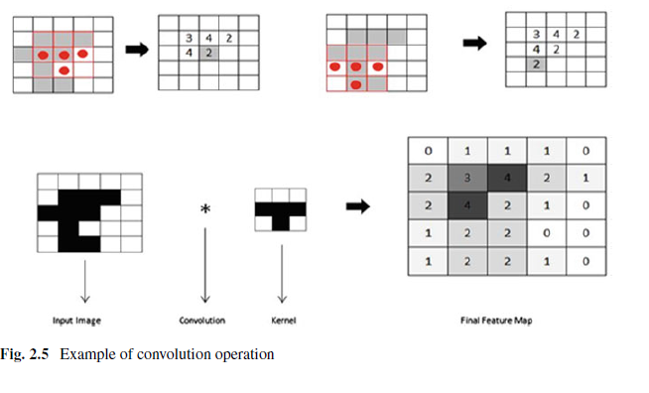

Filters/Kernels
The weights in each convolutional layer specify the convolution filters and there may be multiple filters in each convolutional layer.

Every filter contains some feature like edge, corner, etc. and during forward pass, each filter is slid across the width and height of the input generating feature map of that filter.

Hyperparameters

Convolutional neural network architecture has many hyperparameters that are used to control the behavior of the model. Some of these hyperparameters control the size 22 2 Basics of Supervised Deep Learning of the output while some are used to tune the running time and memory cost of the model.

a.Filter Size: Filters can be of any size greater than 2 × 2 and less than the size of the input but the conventional size varies from 11 × 11 to 3 × 3. The size of a filter is independent of the size of input.

b. Number of Filters: There can be any reasonable number of filters. AlexNet used 96 filters of size 11 × 11 in the first convolution layer. VGGNet used 96 filters of size 7 × 7, and another variant of VGGNet used 64 filters of size 11 × 11 in first convolution layer.

c. Stride: It is the number of pixels to move at a time to define the local receptive field for a filter. Stride of one means to move across and down a single pixel. The value of stride should not be too small or too large. Too small stride will lead to heavily overlapping receptive fields and too large value will overlap less and the resulting output volume will have smaller dimensions spatially.

d. Zero Padding: This hyperparameter describes the number of pixels to pad the input image with zeros. Zero padding is used to control the spatial size of the output volume.

2.5.2 Activation Function (ReLU)

The activation function layer consists of an activation function that takes the feature map
produced by the convolutional layer and generates the activation map as its output.
The activation function is used to transform the activation level of a neuron into an
output signal. An activation function usually has a squashing effect which takes an input (a number), performs some mathematical operation on it and outputs the activation level of a neuron between a given range, e.g., 0 to 1 or −1 to 1.
Types of activation functions:- write the five types of activation functions names
Pooling Layer

the sequence of convolution layer and activation function layer is followed by an optional pooling or down-sampling layer to reduce the spatial size of the input and thus reducing the number of parameters in the network.

There are few pooling techniques available and the most common pooling technique is max-pooling. Max-pooling simply outputs the maximum value in the input region. The input region is a subset of input (usually 2 × 2). For example, if input region is of size 2 × 2, the max-pooling unit will output the maximum of the four values as shown inFig. 2.10.

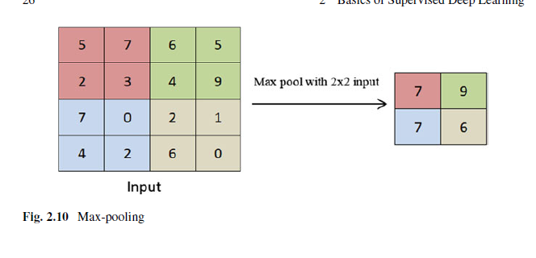
Fully Connected Layer

In ConvNets, the stack of convolution and pooling layers act as feature extraction stage while as the classification stage is composed of one or more fully connected layers followed by a softmax function layer. The process of convolution and pooling continues until enough features are detected. Next step is to make a decision based on these detected features

This is done by adding one or more fully connected layers at the end. In fully connected layer, each neuron from previous layer (convolution layer or pooling layer or fully connected layer) is connected to every neuron in the next layer and every value contributes in predicting how strongly a value matches a particular class
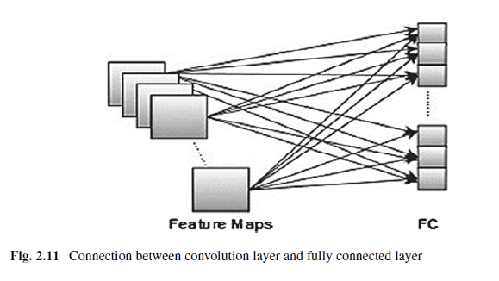
Dropout

Deep neural networks consist of multiple hidden layers enabling it to learn more complicated features. It is followed by fully connected layers for decision-making. A fully connected layer is connected to all features, and it is prone to overfitting.

In order to overcome the problem of overfitting, a dropout layer can be introduced in the model in which some neurons along with their connections are randomly dropped from the network during training (See Fig. 2.12).
A reduced network is left; incoming and outgoing edges to a dropped-out node are also removed. Only the reduced network is trained on the data in that stage. The removed nodes are then reinserted into the network with their original weights. Dropout notably reduces
overfitting and improves the generalization of the model.

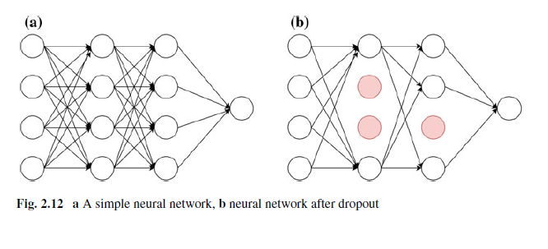

- Explain the deep learning for digit classification.

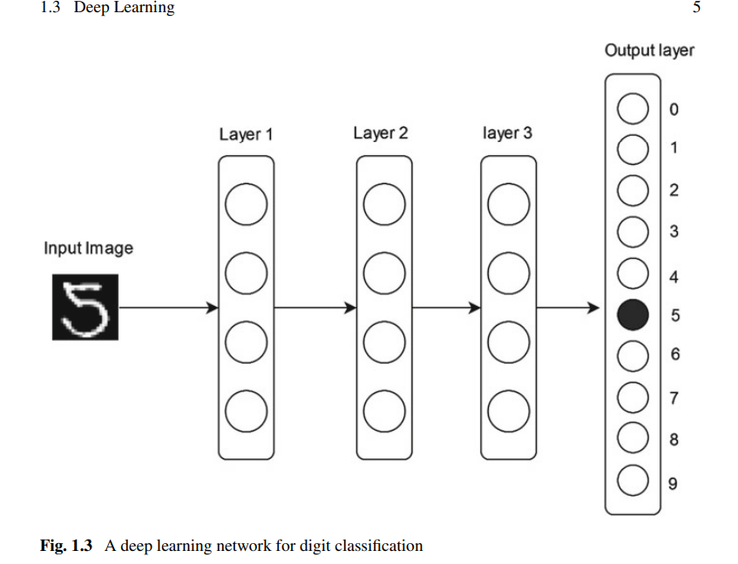
• Improved computational resources for processing massive amounts of data and training much larger models.
• Automatic feature extraction.
The term artificial neural networks has a reference to neuroscience but deep learning networks are not models of the brain; however, deep learning models are formulated by only drawing inspiration from the understanding of biological brain. Not all the components of deep models are inspired by neuroscience; some of them come from empirical exploration, theory, and intuition. The neural activity in our brains is far more complex than might be suggested by simply studying artificial neurons. The learning mechanisms used by deep learning models are in no way comparable to the human brain, but can be described as a mathematical framework for learning representations from data. Figure 1.3 shows an example of a deep learning architecture that can be used for character recognition. Figure 1.4 shows representations that are learned by the deep learning network. The deep network uses several layers to transform the input image (here a digit) in order to recognize what the digit is. Each layer performs some transformations on the input that it receives from the previous layers. The deep network transforms the digit image into representations that tend to capture a higher level of abstraction. Each hidden layer transforms the input image into a representation that is increasingly different from the original image and increasingly informative about the final result. The representations learnt help to distinguish
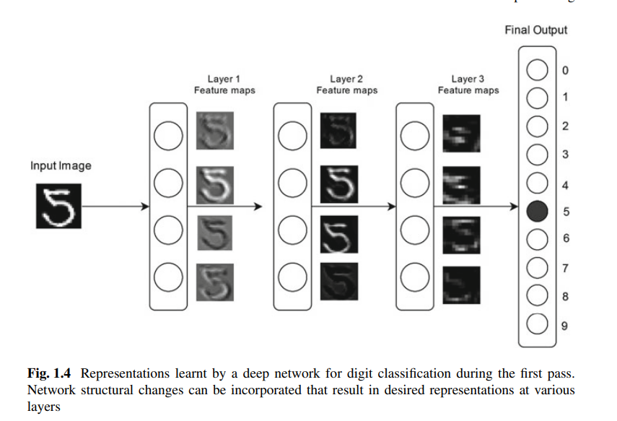
between different concepts which in turn help to find out similarities between it. Deep network can be thought of as a multistage distillation information operation, where layers use multiple filters on the information to obtain an increasingly transformed form of information (i.e., the information useful with regard to some task). In summary, a deep learning network constructs features at multiple levels, with higher features constructed as functions of lower ones. It is a fast-growing field that circumvents the problem of feature extraction which is used as a prelude by conventional machine learning approaches. Deep learning is capable of learning the appropriate features by itself, requiring little steering by the user.

- How the feature extraction will happen in ML and DL?
The effectiveness of any machine learning (ML) system depends greatly on the process of feature extraction. In traditional ML, this was a manual process requiring collaboration between machine learning experts and domain specialists to determine which aspects of the data were most useful. While this approach worked well for structured data, it became extremely challenging for high-dimensional and unstructured data such as images, audio, and video. Practitioners spent decades engineering informative features, but even state-of-the-art ML systems struggled with problems that humans could solve intuitively.
The arrival of deep learning (DL) revolutionized this process. Instead of relying on handcrafted features, deep networks automatically learn features directly from raw data using a general-purpose learning procedure. This automatic feature extraction has allowed DL to surpass conventional ML algorithms in accuracy and generalization. Since 2007, deep learning has achieved remarkable progress in perceptual tasks like vision and speech—areas that were historically difficult for machines. By harnessing vast computational power and large datasets, deep models have demonstrated near-human or even superhuman performance in several domains.
Deep learning has made good impact in historically difficult areas of machine learning:
• Near-human-level image classification;
• Near-human-level speech recognition; • Near-human-level handwriting transcription;
• Improved self-driving cars;
• Digital assistants such as Google Now, Microsoft Cortana, Apple’s Siri, and Amazon Alexa;
• Improved ad targeting, as used by Google, Baidu, and Bing; • Improved search results on the web;
• Ability to answer natural language questions; and
• Superhuman Go, Shogi, and Chess playing
The strength of deep learning lies in its flexibility to represent complex nonlinear functions, efficient training methods, and regularization techniques that ensure strong generalization to unseen data. Its domain-oblivious nature means that the same underlying deep models can be applied to different applications with minimal customization, reducing the need for problem-specific engineering.
Today, leading technology companies such as Facebook, Microsoft, Amazon, Google, and Baidu have deployed DL at scale because it excels when vast amounts of data are available. Beyond industry, it has also attracted scientists from other disciplines who see its potential as a powerful tool for solving complex problems.
Although still considered to be in its infancy, deep learning has already accomplished breakthroughs once thought impossible for machines. Its integration with other AI techniques is expected to spark further innovation, potentially assisting humans in areas such as software development, scientific discovery, and advanced decision-making. With continued growth, deep learning is poised to shape the future of technology and society, delivering solutions in fields as diverse as medicine, finance, manufacturing, education, and beyond.
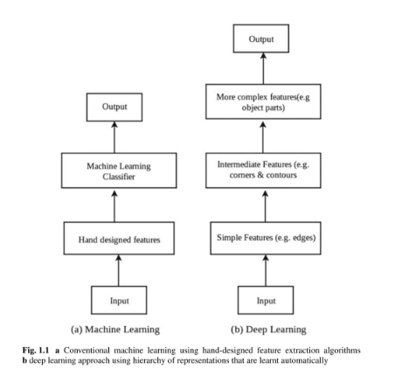
- What is shallow learning? Explain with the neat Diagram.
Shallow architectures are well understood and perform good on many common machine learning problems, and they are still used in a vast majority of today’s machine learning applications. However, there has been an increased interest in deep architectures recently, in the hope to find means to solve more complex real-world problems (e.g., image analysis or natural language understanding) for which shallow architectures are unable to learn models adequately.
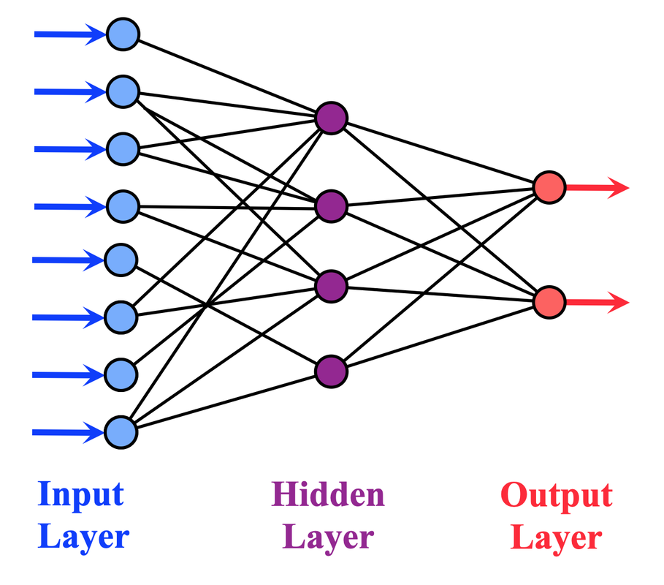

Components of a Shallow Neural Network
- Input Layer: This is where the network receives its input data. Each neuron in this layer represents a feature of the input dataset.
- Hidden Layer: The single hidden layer in a shallow network transforms the inputs into something that the output layer can use. The neurons in this layer apply a set of weights to the inputs and pass them through an activation function to introduce non-linearity to the process.
- Output Layer: The final layer produces the output of the network. For regression tasks, this might be a single neuron; for classification, it could be multiple neurons corresponding to the classes.

How Do Shallow Neural Networks Work
The functionality of shallow neural networks hinges on the transformation of inputs through the hidden layer to produce outputs. Here's a step-by-step breakdown:
- Weighted Sum: Each neuron in the hidden layer calculates a weighted sum of the inputs.
- Activation Function: The weighted sums are passed through an activation function (such as Sigmoid, Tanh, or ReLU) to introduce non-linearity, enabling the network to learn complex patterns.
- Output Generation: The output layer integrates the signals from the hidden layer, often through another set of weights, to produce the final output.

- What are the different data optimizers? Explain.
Gradient Descent-Based Optimization Techniques
Gradient descent is an optimization technique used to minimize/maximize the cost function by calculating gradients necessary to update the values of the parameters of the network. Various variants of this optimizing technique define how to calculate the parameter updates using these gradients.
Gradient Descent Variants
There are three commonly used Gradient Descent (GD) variants. These variants differ in how many training examples are used to compute the gradient. The three variants are explained as follows.
1. Batch Gradient Descent (GD)
In traditional Gradient Descent (GD), also known as batch gradient descent, error gradient with respect to weight parameter w is computed for the entire training set followed by updating the weight parameter as shown below:
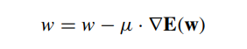
where ∇E(w) is the error gradient with respect to weight w and µ is the learning rate that defines the step size to take along the gradient. The learning rate is a hyperparameter which cannot be too high or too low. Large value of learning rate can miss the optimum value, and too low learning rate will result in slow training time. The training set often contains hundreds and thousands of examples that may demand huge memory which makes it difficult to fit in the memory. As a result, computing the error gradient can be very slow.
2. Stochastic Gradient Descent (SGD)
The above problem can be rectified by using Stochastic Gradient Descent (SGD), also known as incremental gradient descent, where gradient is computed for one training example at a time followed by updating of parameter values. It is usually much faster than standard gradient descent as it performs one update at a time.
w = μ.∇E(w; x(i); y(i))
where ∇E(w; x(i); y(i)) is the gradient of loss function—E(w) w.r.t parameters w, for the training example {x(i), y(i)}. In SGD, the one example based on updation of the parameter values causes the loss function to fluctuate frequently.
3. Mini-batch Gradient Descent
Mini-batch gradient descent also known as mini-batch SGD is a combination of both standard gradient descent and SGD techniques. Mini-batch SGD divides the entire training set into mini-batches of n training examples and performs the updating of parameter values for each mini-batch. This type of gradient descent technique takes advantage of both standard gradient descent and SGD techniques, and is commonly used optimization technique in deep learning.
2. Improving Gradient Descent for Faster Convergence
The main objective of optimization is to minimize the cost/loss or objective function. There are many methods available that help an optimization algorithm to converge faster. Some of the commonly used methods are discussed below.
1 AdaGrad
To overcome this issue, adaptive optimization algorithms were introduced. Instead of keeping the learning rate fixed, they automatically adjust the learning rate for each parameter based on past gradients. One such algorithm is AdaGrad (Adaptive Gradient Algorithm).
AdaGrad adapts the learning rate for each parameter individually by taking into account the history of gradients.
The update rule is:
wt+1,I = wt,i − μ √Gi · ∇t,i
Where:
- wt,iw_{t,i}wt,i​ = parameter at time t
- μ\muμ = initial global learning rate
- ∇t,i\nabla_{t,i}∇t,i​ = gradient of loss function w.r.t parameter wiw_iwi​ at iteration t
- Gi=∑τ=1t(∇τ,i)2G_i = \sum_{\tau=1}^t (\nabla_{\tau,i})^2Gi​=∑τ=1t​(∇τ,i​)2 = accumulated sum of squared gradients of parameter wiw_iwi​ up to iteration t
2. AdaDelta
AdaDelta is a modified version of AdaGrad which overcomes the problem of decaying leaning rate. AdaDelta limits the number of previous gradients to some fixed size x and then the average of these past gradients is stored for efficiency. The average value Avg( ∇2t )at time t only depends on previous average and current gradient. The parameter update is then made as
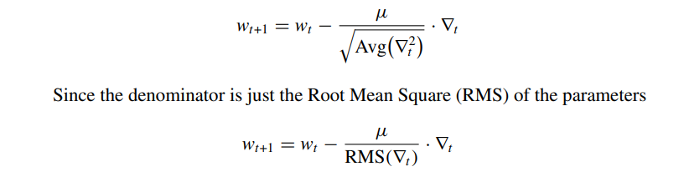
3. RMSProp
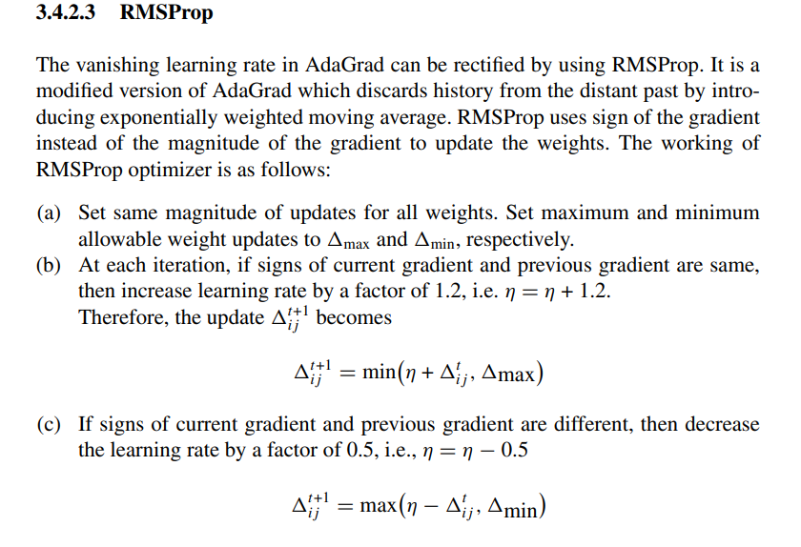
- Adam
Adaptive Moment Estimation (Adam) is an adaptive optimization technique that takes advantages of AdaGrad and RMSProp. Like AdaDelta and RMSProp, Adam saves an exponentially decaying average of previous squared gradients vt. In addition to that, Adam also computes the average of the second moments of the gradients mt.
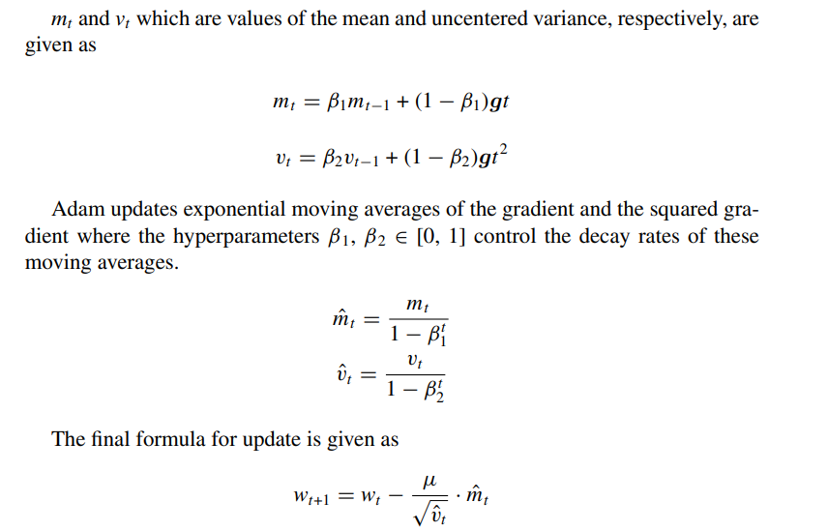
Adam slightly performs better than other adaptive techniques and converges very fast. It also overcomes the problems faced by other optimization techniques such as decaying learning rate, high variance in updates, and slow convergence. Note that a smoothing term ’e’ is usually added in the denominator of the above fast converging methods to avoid divide by 0.
TUTORIAL:-
